

**BACHELOR OF COMPUTER SCIENCE (HONOURS)**

**UCCD1004 PROGRAMMING CONCEPTS AND PRATICES**

|  |  |
| --- | --- |
| **Name** | Lee Jian Zhen |
| **Student ID** | 19ACB02281 |
| **Email Address** | jianzhen@1utar.my |

|  |  |  |
| --- | --- | --- |
| No. | Content. | Page. |
| 1 | Objective | 2 |
| 2 | Pseudocode | 2 |
| 3 | Flowchart | 3 - 4 |
| 4 | Test Case | 5 - 10 |
| 5 | Source Code | 11 - 29 |

**Objective**

Write a C++ program (without using any library functions other than iostream, string and iomanip) which enable an admin to book a ZOOM account (on behalf of lecturers) for a particular course to conduct online classes.

**Pseudocode**

Declare all variable with suitable data types

REPEAT

_INPUT course code and name, number of students.

___IF number of students more than 250.

_____INPUT time slot.

_____IF particular time selected.

_______IF occupied.

_________Display course code and name.

_________Ask for update/cancel/remain.

_________IF update.

___________Replace the occupied data with new data.

_________ELSE IF cancel.

___________Delete the occupied data.

_________ELSE IF remain.

___________Remain the data.

_______ELSE book successful.

___ELSE number of students less than or equal to 250.

_____INPUT zoom slot.

_____IF particular zoom selected.

_______INPUT time slot.

_______IF particular time selected.

_________IF occupied.

___________Display course code and name.

___________Ask for update/cancel/remain.

___________IF update.

_____________Replace the occupied data with new data.

___________ELSE IF cancel.

_____________Delete the occupied data.

___________ELSE IF remain.

_____________Remain the data.

_________ELSE book successful.

Display Total Booking and Booked slot.

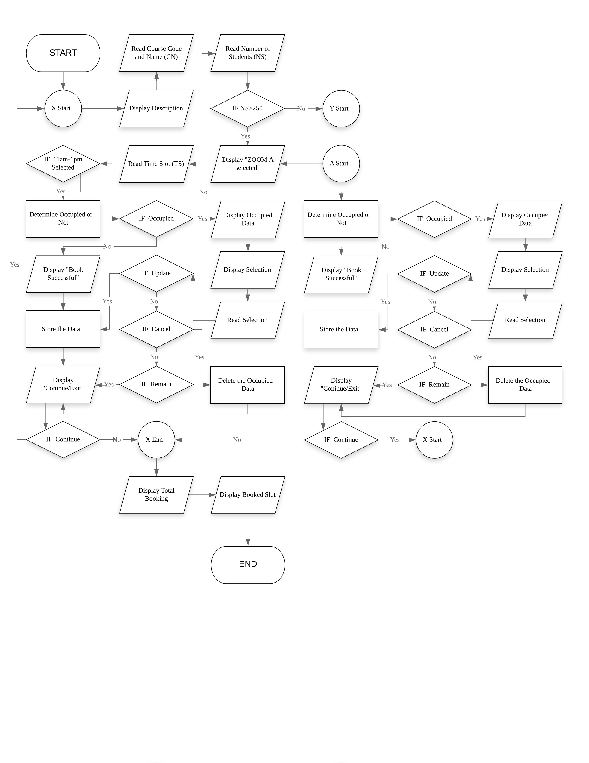**Flowchart**

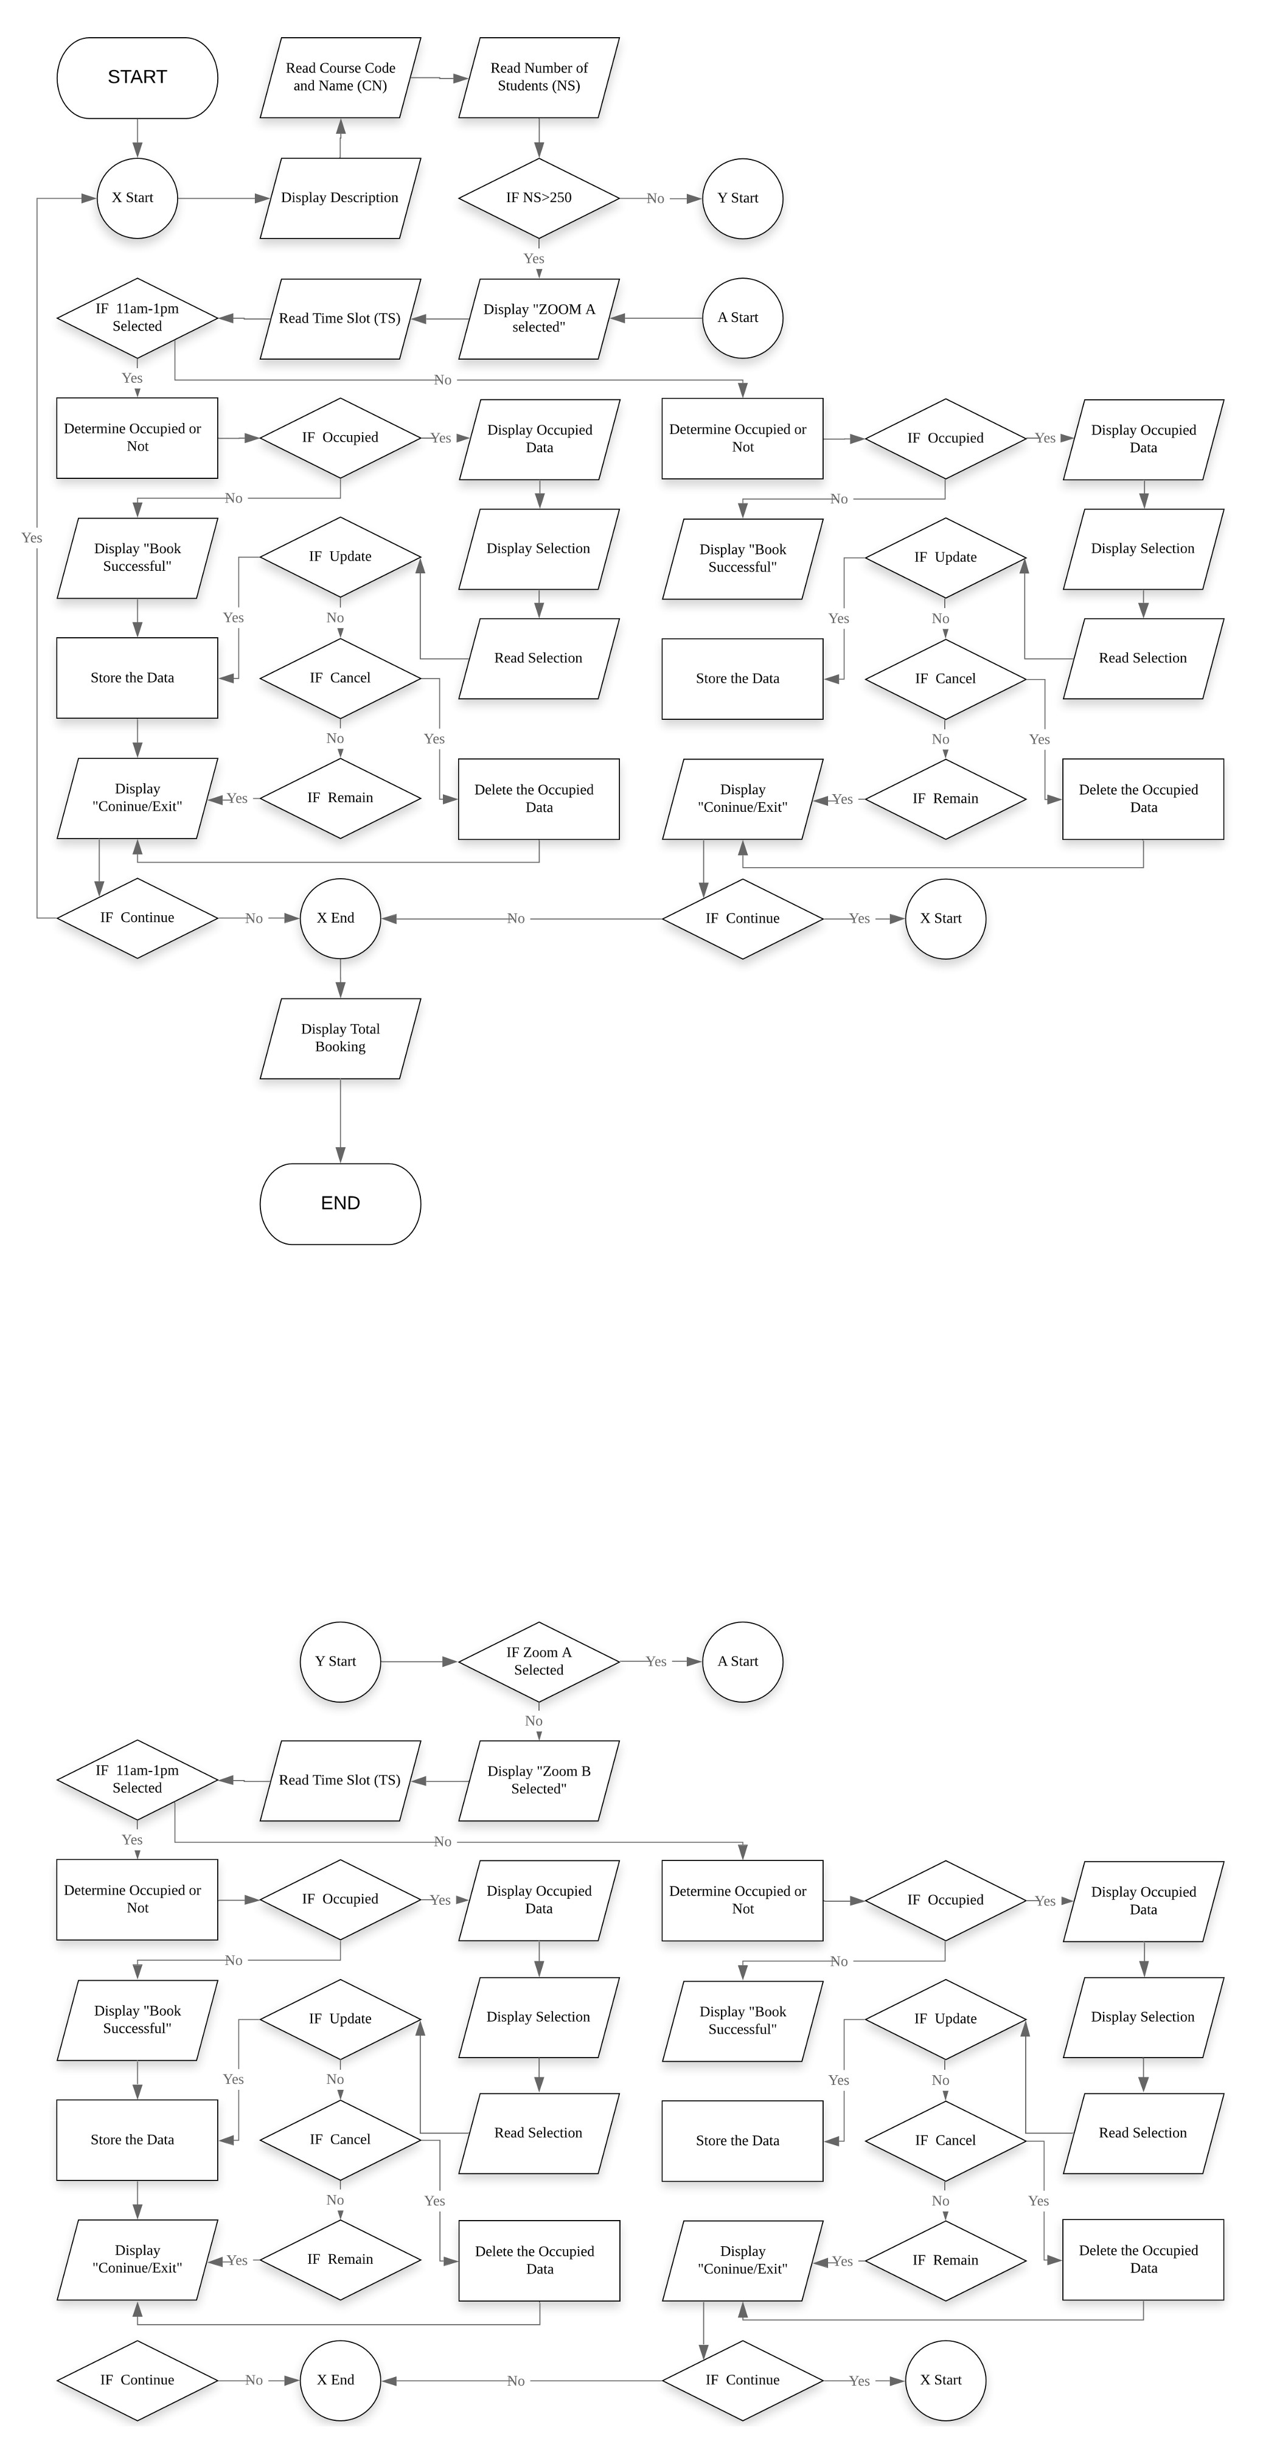**Flowchart continues**

**Test Case**

Course code and name:

1. UCCD1004 Programming Concepts and Practices
2. UCCD1143 Probability and Statistics for Computing
3. UCCN1004 Data Communications and Networking
4. UCCM1153 Introduction to Calculus and Applications

Zoom account:

1. Zoom A
2. Zoom B

Time slot:

1. 11a.m. ~ 1p.m.
2. 2a.m. ~ 4p.m.

|  |  |  |
| --- | --- | --- |
| No. | Test Case | Page. |
| 1 | Identify booked account | 6 - 7 |
| 2 | Update and Cancel the Zoom account | 8 |
| 3 | Total bookings | 10 |
| 4 | Input validation | 10 |

**Test Case 1: Identify the booked Zoom account**

First, I insert the course code and name **(UCCD1004 Programming Concepts and Practices)** and input the **number of students (263)**. After that, the system will **select Zoom A automatically** because of number of students more than 250 and we select the time **(11a.m. ~ 1p.m.)** and it show success.

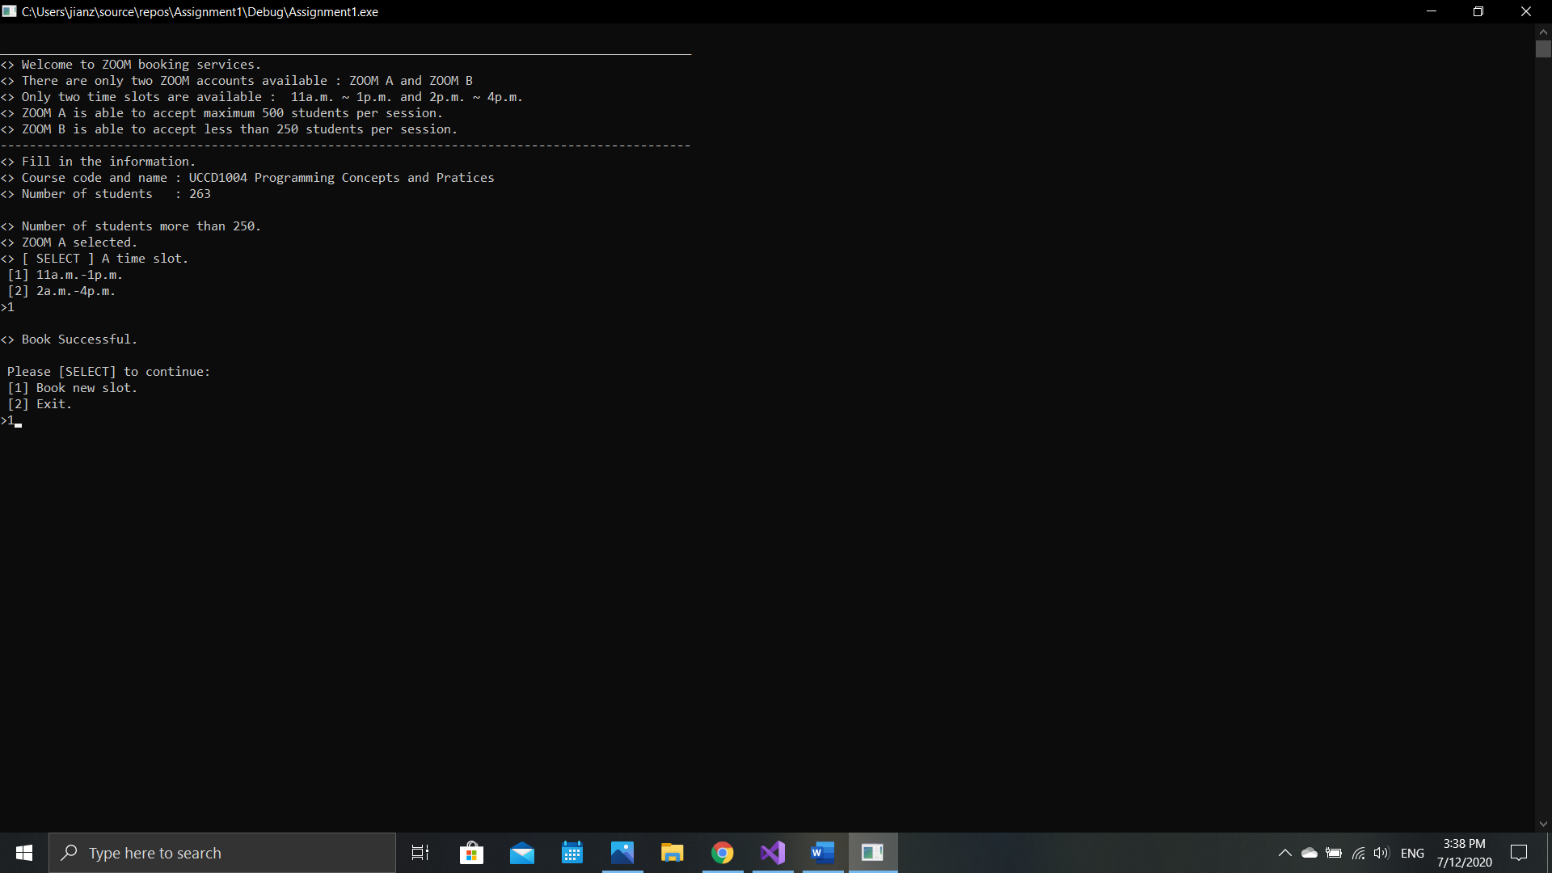

I select Book new slot for continue booking, then I insert the second course code and name **(UCCD1143 Probability and Stastistics for Computing)**, number of **students (322)** which number of students more than 250 **(Zoom A selected)** and select the **time (2p.m. ~ 4p.m.)**. As we know that we had booked an account for UCCD1004 Programming Concepts and Practices which was Zoom A and 11a.m. ~ 1p.m. As a result, the Zoom account was occupied and the system will show the occupied account details.

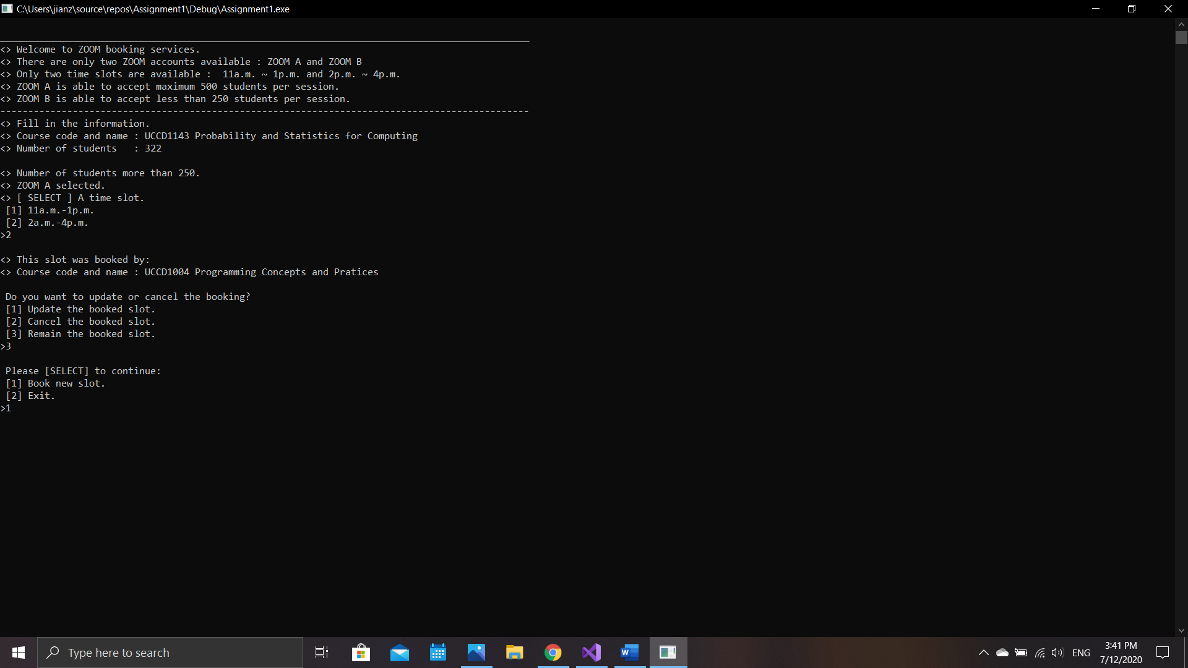

Afterward, I insert again the course code and name **(UCCD1004 Programming Concepts and Practices)** and number of **students (233**). Since the number of students less than 250, we can select both of the Zoom account so I select **Zoom A and 11a.m. ~ 1p.m**. Just now, I had booked an account which was the same course code and name so that the system now shows us that we had book the entire slot.

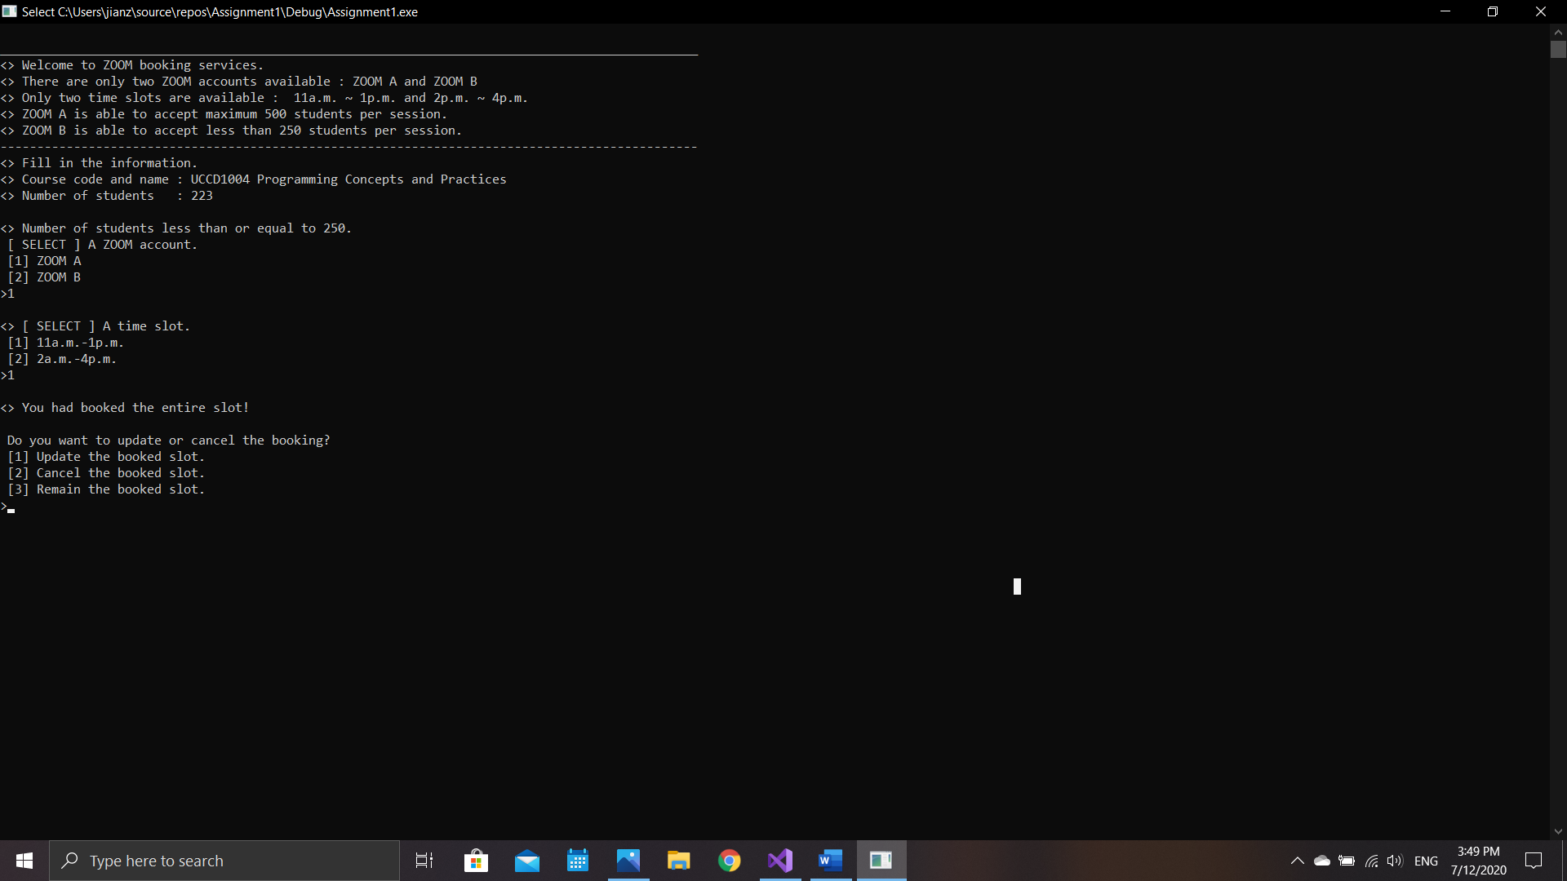

**Test Case 2: Update and Cancel the Zoom account**

First, we book a Zoom account with course code and name **(UCCD1004 Programming Concepts and Practices), number of students (320), Zoom A, and time 11a.m. ~ 1p.m**. Then, we book another account with course code and name **(UCCD1143 Probability and Statistics for Computing), total students (340), Zoom A, and time 2p.m. ~ 4p.m**. It will show occupied and we try to update the first account to second account.

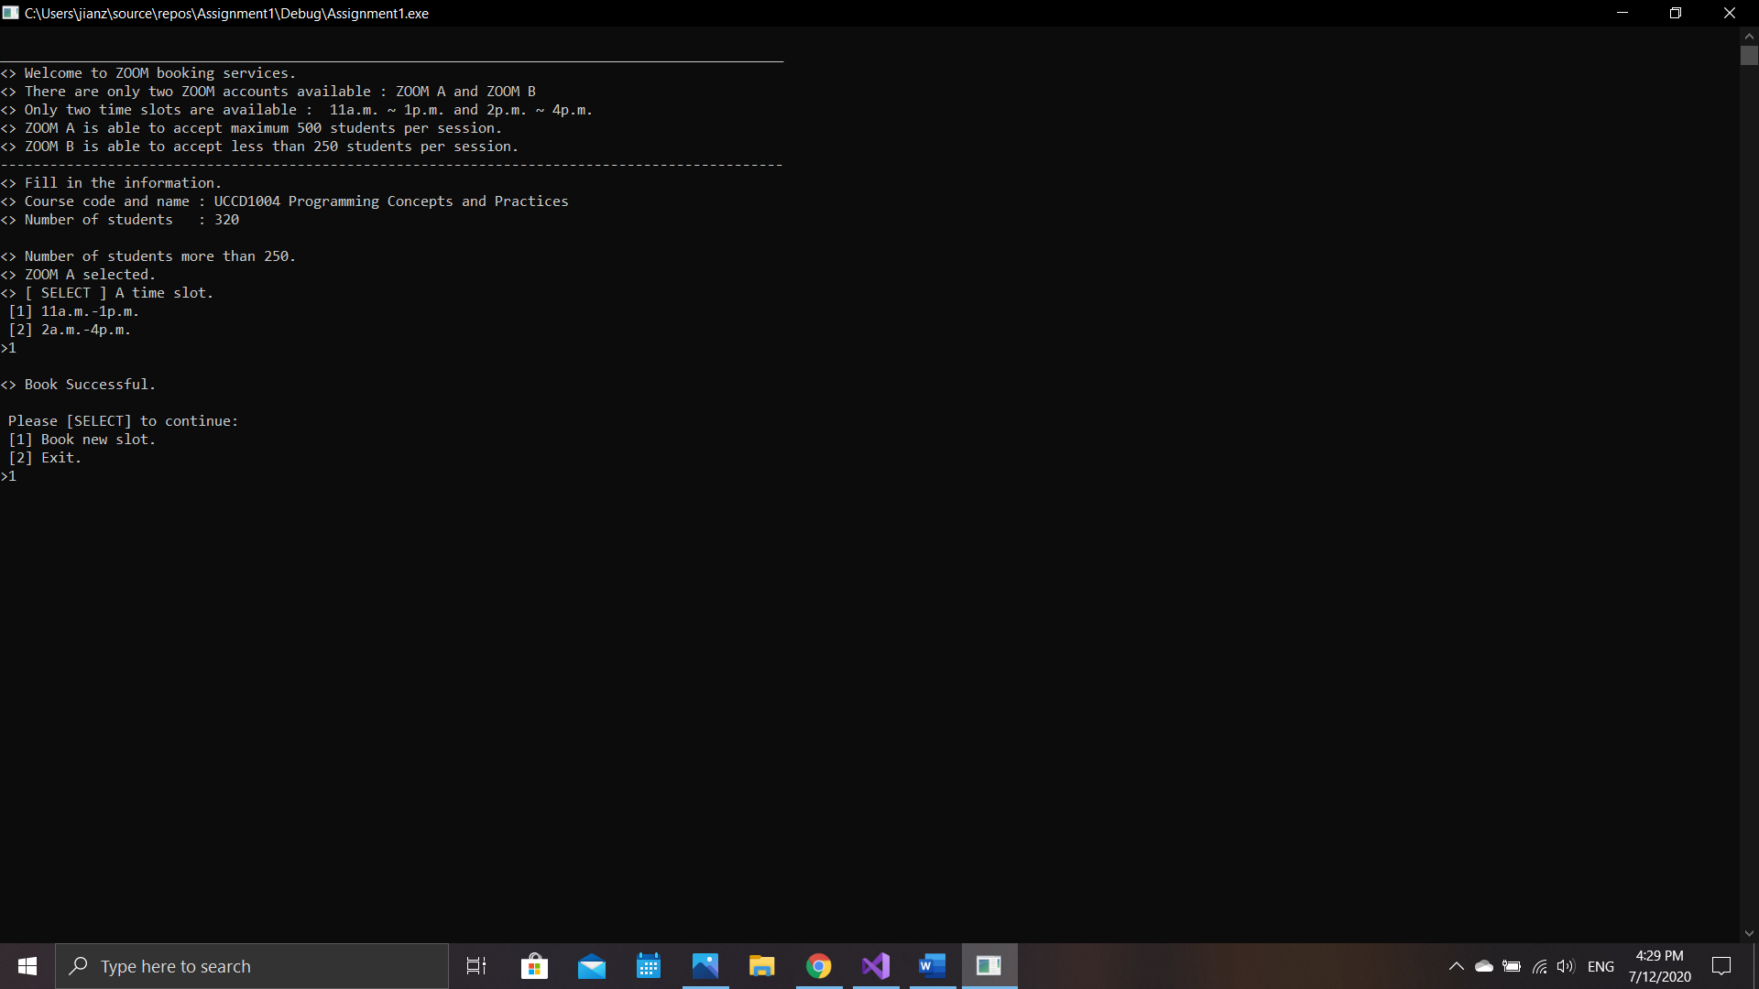

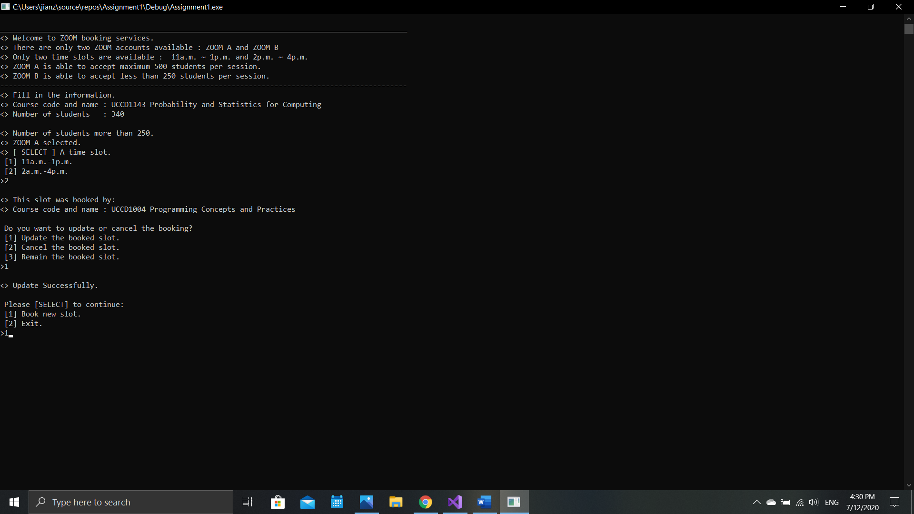

Next, we book an zoom account with course code and name **(UCCN1004 Data Communications and Networking), total stutends (310), Zoom A, and time 11a.m. ~ 1p.m.** Then the system will show the occupied details which is the second zoom account we booked. We try to cancel the occupied account and test whether we can book the same account or not.

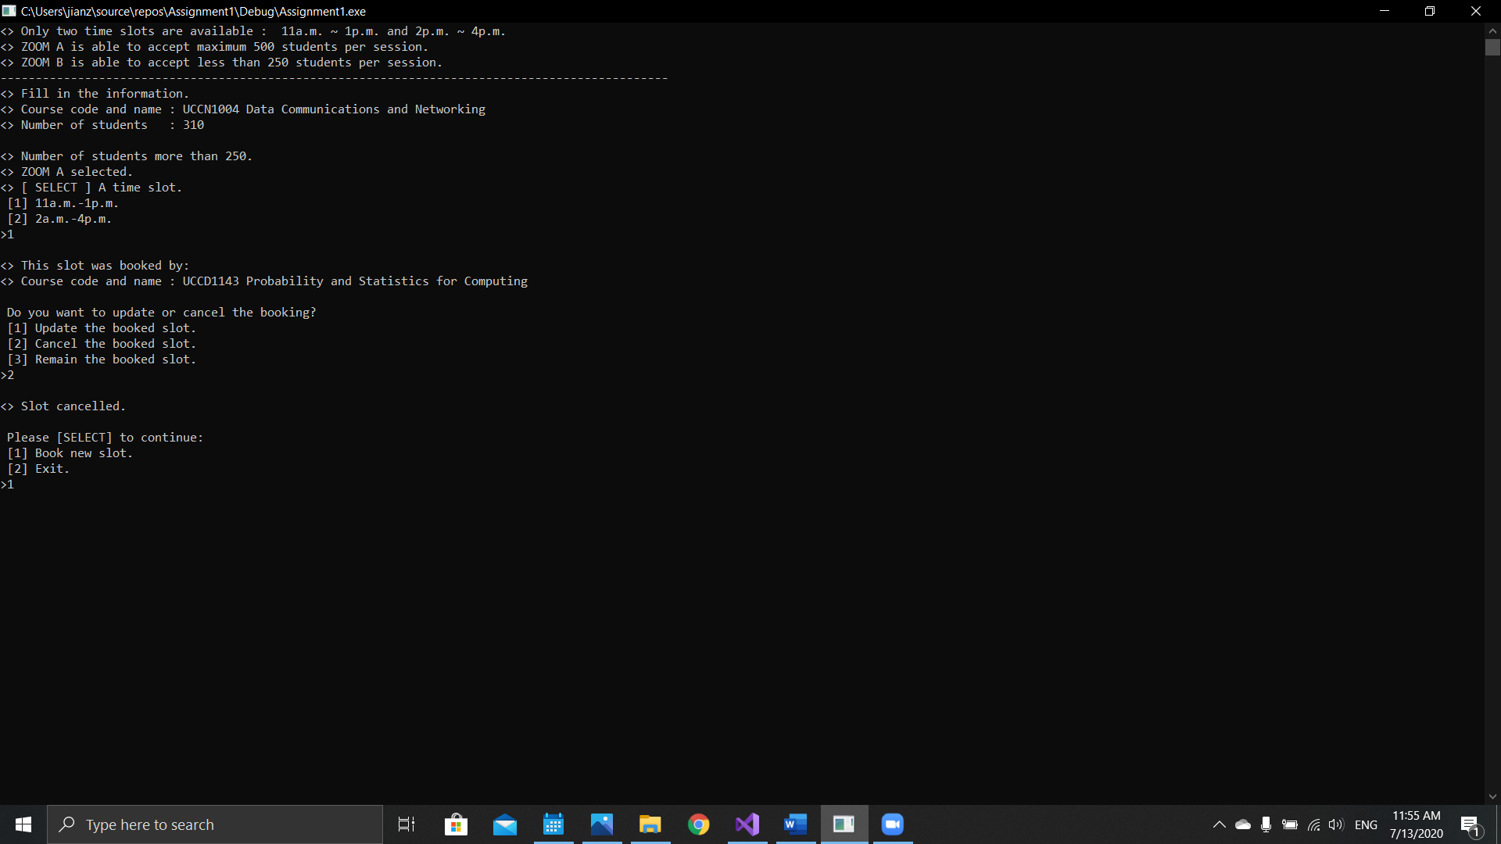

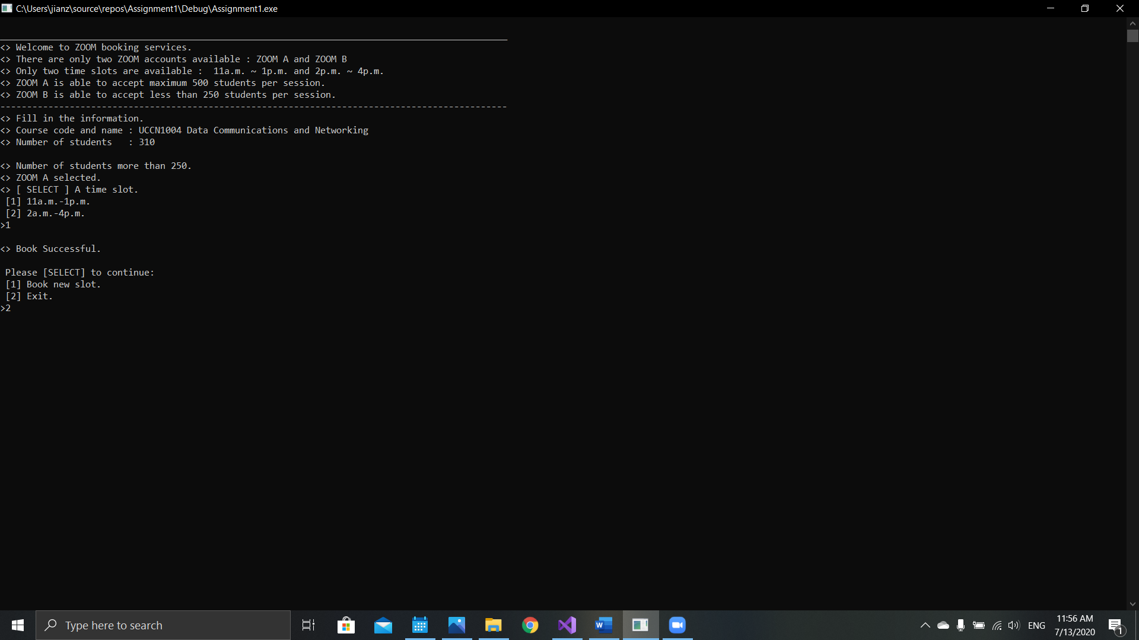

At the end, we are able to book the account that we cancelled just now.

**Test Case 3: Total bookings**

In test case 2, we had book 2 empty zoom account successfully. At the same time, we also test the update and cancel function each once. At the end, we had just booked one account since we cancelled one account just now.

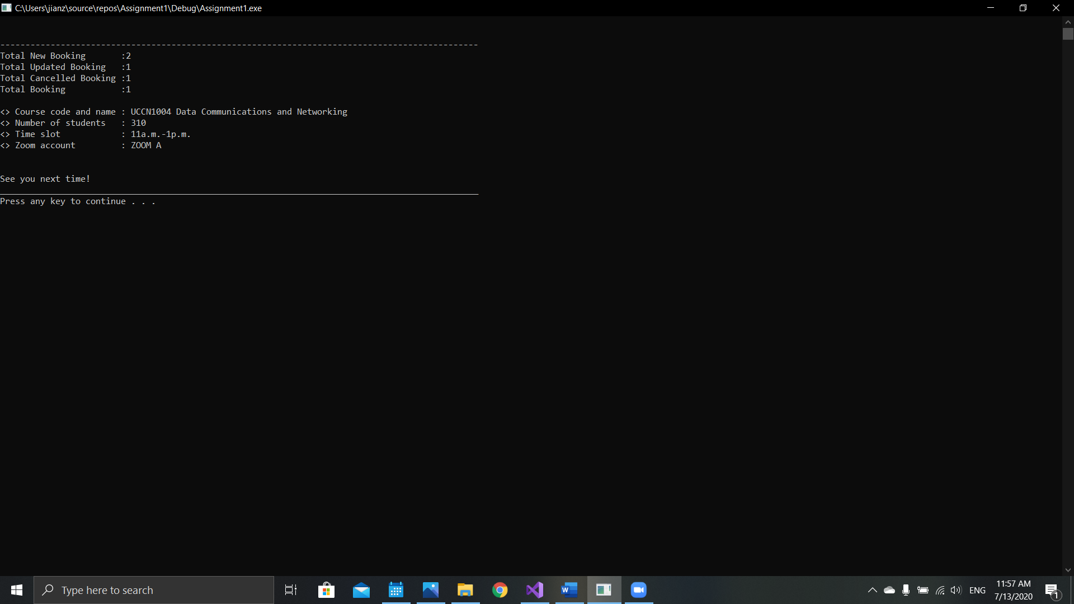

**Test Case 4: Input validations**

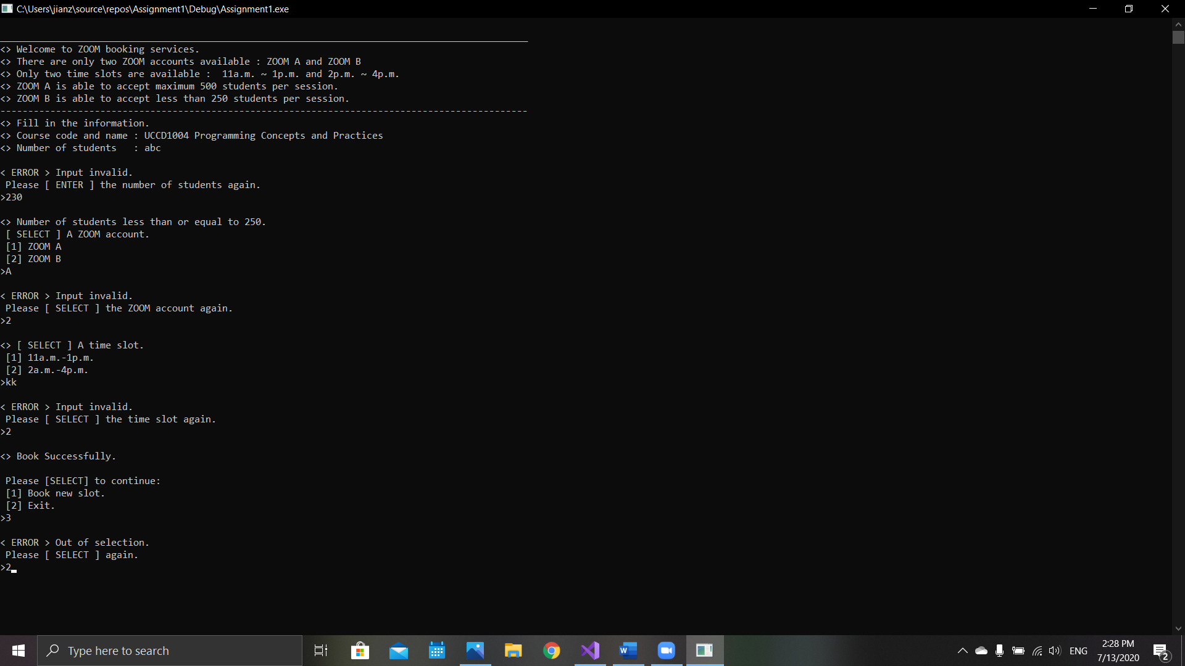All of the input will only accept integers instead of character or string.

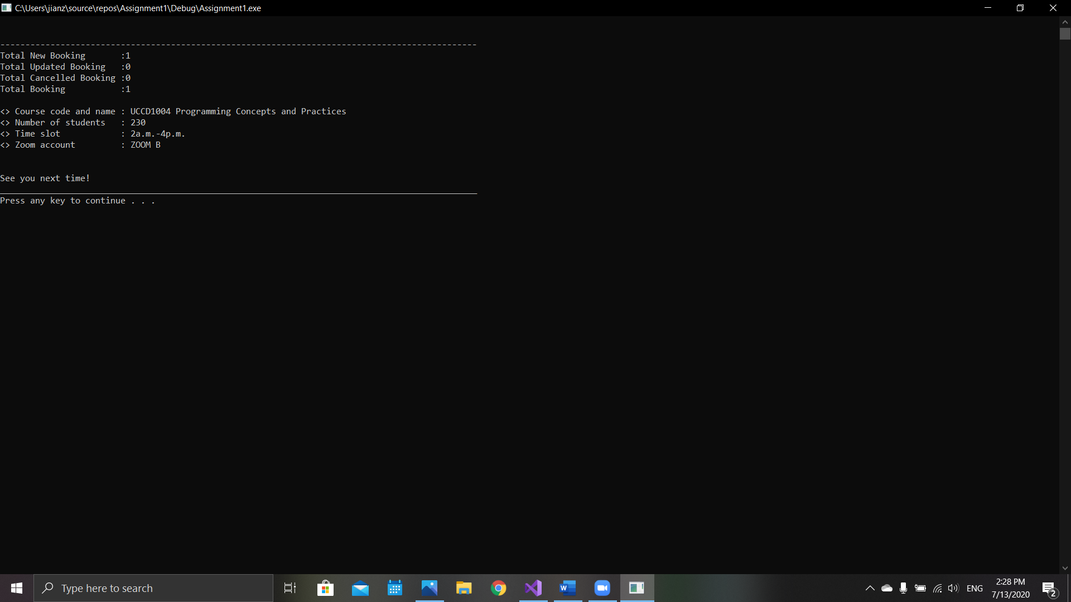

**Source Code**

#include<iostream>

#include<iomanip>

#include<string>

using namespace std;

int main(void) {

//Course Code and Name.

string CN, CN1, CN2, CN3, CN4;

CN = "", CN1 = "", CN2 = "", CN3 = "", CN4 = "";

//Number of Students.

int NS, NS1, NS2, NS3, NS4;

NS = 0, NS1 = 0, NS2 = 0, NS3 = 0, NS4 = 0;

//Time Slots.

int TS = 0;

string TSC, TSD;

TSC = "11a.m.-1p.m.";

TSD = "2a.m.-4p.m.";

int C = 0, D = 0;

//ZOOM Accounts.

int ZA = 0;

string ZAA = "ZOOM A";

string ZAB = "ZOOM B";

int A = 0, B = 0;

//Booked account.

int AC, AD, BC, BD;

AC = 0, AD = 0, BC = 0, BD = 0;

//Display.

string Dcn = "<> Course code and name";

string Dns = "<> Number of students";

string Dts = "<> Time slot";

string Dza = "<> Zoom account";

//Count.

int NB = 0, UB = 0, CB = 0, TB = 0;

//Decisions.

int select;

bool valid = false, end_valid = false;

do {

cout << "\n_______________________________________________________________________________________________\n";

cout << "<> Welcome to ZOOM booking services.\n";

cout << "<> There are only two ZOOM accounts available : ZOOM A and ZOOM B\n";

cout << "<> Only two time slots are available : 11a.m. ~ 1p.m. and 2p.m. ~ 4p.m.\n";

cout << "<> ZOOM A is able to accept maximum 500 students per session.\n";

cout << "<> ZOOM B is able to accept less than 250 students per session.\n";

cout << "-----------------------------------------------------------------------------------------------\n";

cout << "<> Fill in the information.\n";

cout << setw(24) << left << Dcn << ": ";

getline(cin, CN);

cout << setw(24) << left << Dns << ": ";

do {

if (cin >> NS) {

cin.ignore();

if (NS > 0 && NS < 501) {

valid = true;

}

else {

cout << " \n< ERROR > Number is out of limit.\n" << " Please [ ENTER ] the number of students again.\n" << ">";

continue;

}

}

else {

cin.clear();

cin.ignore(10000, '\n');

cout << " \n< ERROR > Input invalid.\n" << " Please [ ENTER ] the number of students again.\n" << ">";

}

} while (!valid);

valid = false;

if (NS > 250) {

cout << "\n<> Number of students more than 250.\n" << "<> ZOOM A selected.\n";

cout << "<> [ SELECT ] A time slot.\n" << " [1] " << TSC << "\n [2] " << TSD << "\n>";

do {

if (cin >> TS) {

cin.ignore();

if (TS > 0 && TS < 3) {

valid = true;

}

else {

cout << " \n< ERROR > Out of selection.\n" << " Please [ SELECT ] the time slot again.\n" << ">";

continue;

}

}

else {

cin.clear();

cin.ignore(10000, '\n');

cout << " \n< ERROR > Input invalid.\n" << " Please [ SELECT ] the time slot again.\n" << ">";

}

} while (!valid);

valid = false;

if (TS == 1) {

if (A == 1 || C == 1) {

if (CN1 == CN) {

cout << "\n<> You had booked the entire slot! \n";

}

else if (AD == 1 && BC == 1) {

cout << "\n<> This slot was booked by: \n";

cout << setw(24) << left << Dcn << ": " << CN2 << endl;

cout << setw(24) << left << Dcn << ": " << CN3 << endl;

}

else if (AC == 1) {

cout << "\n<> This slot was booked by: \n";

cout << setw(24) << left << Dcn << ": " << CN1 << endl;

}

else if (BC == 0) {

cout << "\n<> This slot was booked by: \n";

cout << setw(24) << left << Dcn << ": " << CN2 << endl;

}

else if (AD == 0) {

cout << "\n<> This slot was booked by: \n";

cout << setw(24) << left << Dcn << ": " << CN3 << endl;

}

cout << " \n Do you want to update or cancel the booking?\n" << " [1] Update the booked slot.\n" << " [2] Cancel the booked slot.\n"<<" [3] Remain the booked slot.\n" << ">";

do {

if (cin >> select) {

cin.ignore();

if (select > 0 && select < 4) {

valid = true;

}

else {

cout << " \n< ERROR > Out of selection.\n" << " Please [ SELECT ] again.\n" << ">";

continue;

}

}

else {

cin.clear();

cin.ignore(10000, '\n');

cout << " \n< ERROR > Input invalid.\n" << " Please [ SELECT ] again.\n" << ">";

}

} while (!valid);

valid = false;

if (select == 1) {

if (AD == 1 && BC == 1) {

AD = 0, BC = 0, A = 0, B = 0, C = 0, D = 0;

}

else if (BC == 0) {

AD = 0, A = 0, D = 0;

}

else if (AD == 0) {

}

AC = 1, A = 1, C = 1;

UB++;

cout << "\n<> Update Successfully.\n";

CN1 = CN, NS1 = NS;

}

else if (select == 2) {

if (AD == 1 && BC == 1) {

AD = 0, BC = 0, A = 0, B = 0, C = 0, D = 0;

CN2 = "", CN3 = "";

}

else if (AC == 1) {

AC = 0, A = 0, C = 0;

CN1 = "";

}

else if (BC == 0) {

AD = 0, A = 0, D = 0;

CN2 = "";

}

else if (AD == 0) {

BC = 0, B = 0, C = 0;

CN3 = "";

}

CB++, TB--;

cout << "\n<> Slot cancelled.\n";

}

}

else {

NB++, TB++;

cout << "\n<> Book Successful.\n";

AC = 1, A = 1, C = 1;

CN1 = CN, NS1 = NS;

}

cout << "\n Please [SELECT] to continue:\n" << " [1] Book new slot.\n" << " [2] Exit.\n" << ">";

do {

if (cin >> select) {

cin.ignore();

if (select > 0 && select < 3) {

valid = true;

}

else {

cout << " \n< ERROR > Out of selection.\n" << " Please [ SELECT ] again.\n" << ">";

continue;

}

}

else {

cin.clear();

cin.ignore(10000, '\n');

cout << " \n< ERROR > Input invalid.\n" << " Please [ SELECT ] again.\n" << ">";

}

if (select == 2) {

end_valid = true;

}

} while (!valid);

valid = false;

system("cls");

}

else {

if (A == 1 || D == 1) {

if (CN2 == CN) {

cout << "\n<> You had booked the entire slot! \n";

}

else if (AC == 1 && BD == 1) {

cout << "\n<> This slot was booked by: \n";

cout << setw(24) << left << Dcn << ": " << CN1 << endl;

cout << setw(24) << left << Dcn << ": " << CN4 << endl;

}

else if (AD == 1) {

cout << "\n<> This slot was booked by: \n";

cout << setw(24) << left << Dcn << ": " << CN2 << endl;

}

else if (BD == 0) {

cout << "\n<> This slot was booked by: \n";

cout << setw(24) << left << Dcn << ": " << CN1 << endl;

}

else if (AC == 0) {

cout << "\n<> This slot was booked by: \n";

cout << setw(24) << left << Dcn << ": " << CN4 << endl;

}

cout << " \n Do you want to update or cancel the booking?\n" << " [1] Update the booked slot.\n" << " [2] Cancel the booked slot.\n" << " [3] Remain the booked slot.\n" << ">";

do {

if (cin >> select) {

cin.ignore();

if (select > 0 && select < 4) {

valid = true;

}

else {

cout << " \n< ERROR > Out of selection.\n" << " Please [ SELECT ] again.\n" << ">";

continue;

}

}

else {

cin.clear();

cin.ignore(10000, '\n');

cout << " \n< ERROR > Input invalid.\n" << " Please [ SELECT ] again.\n" << ">";

}

} while (!valid);

valid = false;

if (select == 1) {

if (AC == 1 && BD == 1) {

AC = 0, BD = 0, A = 0, C = 0, B = 0, D = 0;

}

else if (BD == 0) {

AC = 0, A = 0, C = 0;

}

else if (AC == 0) {

BD = 0, B = 0, D = 0;

}

AD = 1, A = 1, D = 1;

UB++;

cout << "\n<> Update Successfully.\n";

CN2 = CN, NS2 = NS;

}

else if (select == 2) {

if (AC == 1 && BD == 1) {

AC = 0, BD = 0, A = 0, C = 0, B = 0, D = 0;

CN1 = "", CN4 = "";

}

else if (AD == 1) {

AD = 0, A = 0, D = 0;

CN2 = "";

}

else if (BD == 0) {

AC = 0, A = 0, C = 0;

CN1 = "";

}

else if (AC == 0) {

BD = 0, B = 0, D = 0;

CN4 = "";

}

CB++, TB--;

cout << "\n<> Slot cancelled.\n";

}

}

else {

NB++, TB++;

cout << "\n<> Book Successfully.\n";

AD = 1, A = 1, D = 1;

CN2 = CN, NS2 = NS;

}

cout << "\n Please [SELECT] to continue:\n" << " [1] Book new slot.\n" << " [2] Exit.\n" << ">";

do {

if (cin >> select) {

cin.ignore();

if (select > 0 && select < 3) {

valid = true;

}

else {

cout << " \n< ERROR > Out of selection.\n" << " Please [ SELECT ] again.\n" << ">";

continue;

}

}

else {

cin.clear();

cin.ignore(10000, '\n');

cout << " \n< ERROR > Input invalid.\n" << " Please [ SELECT ] again.\n" << ">";

}

if (select == 2) {

end_valid = true;

}

} while (!valid);

valid = false;

system("cls");

}

}

else {

cout << "\n<> Number of students less than or equal to 250.";

cout << "\n [ SELECT ] A ZOOM account." << "\n [1] ZOOM A" << "\n [2] ZOOM B" << "\n>";

do {

if (cin >> ZA) {

cin.ignore();

if (ZA > 0 && ZA < 3) {

valid = true;

}

else {

cout << " \n< ERROR > Out of selection.\n" << " Please [ SELECT ] the ZOOM account again.\n" << ">";

continue;

}

}

else {

cin.clear();

cin.ignore(10000, '\n');

cout << " \n< ERROR > Input invalid.\n" << " Please [ SELECT ] the ZOOM account again.\n" << ">";

}

} while (!valid);

valid = false;

cout << "\n<> [ SELECT ] A time slot.\n" << " [1] " << TSC << "\n [2] " << TSD << "\n>";

do {

if (cin >> TS) {

cin.ignore();

if (TS > 0 && TS < 3) {

valid = true;

}

else {

cout << " \n< ERROR > Out of selection.\n" << " Please [ SELECT ] the time slot again.\n" << ">";

continue;

}

}

else {

cin.clear();

cin.ignore(10000, '\n');

cout << " \n< ERROR > Input invalid.\n" << " Please [ SELECT ] the time slot again.\n" << ">";

}

} while (!valid);

valid = false;

if (ZA == 1) {

if (TS == 1) {

if (A == 1 || C == 1) {

if (CN1 == CN) {

cout << "\n<> You had booked the entire slot! \n";

}

else if (AD == 1 && BC == 1) {

cout << "\n<> This slot was booked by: \n";

cout << setw(24) << left << Dcn << ": " << CN2 << endl;

cout << setw(24) << left << Dcn << ": " << CN3 << endl;

}

else if (AC == 1) {

cout << "\n<> This slot was booked by: \n";

cout << setw(24) << left << Dcn << ": " << CN1 << endl;

}

else if (BC == 0) {

cout << "\n<> This slot was booked by: \n";

cout << setw(24) << left << Dcn << ": " << CN2 << endl;

}

else if (AD == 0) {

cout << "\n<> This slot was booked by: \n";

cout << setw(24) << left << Dcn << ": " << CN3 << endl;

}

cout << " \n Do you want to update or cancel the booking?\n" << " [1] Update the booked slot.\n" << " [2] Cancel the booked slot.\n" << " [3] Remain the booked slot.\n" << ">";

do {

if (cin >> select) {

cin.ignore();

if (select > 0 && select < 4) {

valid = true;

}

else {

cout << " \n< ERROR > Out of selection.\n" << " Please [ SELECT ] again.\n" << ">";

continue;

}

}

else {

cin.clear();

cin.ignore(10000, '\n');

cout << " \n< ERROR > Input invalid.\n" << " Please [ SELECT ] again.\n" << ">";

}

} while (!valid);

valid = false;

if (select == 1) {

if (AD == 1 && BC == 1) {

AD = 0, BC = 0, A = 0, B = 0, C = 0, D = 0;

}

else if (BC == 0) {

AD = 0, A = 0, D = 0;

}

else if (AD == 0) {

BC = 0, B = 0, C = 0;

}

AC = 1, A = 1, C = 1;

UB++;

cout << "\n<> Update Successfully.\n";

CN1 = CN, NS1 = NS;

}

else if (select == 2) {

if (AD == 1 && BC == 1) {

AD = 0, BC = 0, A = 0, B = 0, C = 0, D = 0;

CN2 = "", CN3 = "";

}

else if (AC == 1) {

AC = 0, A = 0, C = 0;

CN1 = "";

}

else if (BC == 0) {

AD = 0, A = 0, D = 0;

CN2 = "";

}

else if (AD == 0) {

BC = 0, B = 0, C = 0;

CN3 = "";

}

CB++, TB--;

cout << "\n<> Slot cancelled.\n";

}

}

else {

NB++, TB++;

cout << "\n<> Book Successful.\n";

AC = 1, A = 1, C = 1;

CN1 = CN, NS1 = NS;

}

cout << "\n Please [SELECT] to continue:\n" << " [1] Book new slot.\n" << " [2] Exit.\n" << ">";

do {

if (cin >> select) {

cin.ignore();

if (select > 0 && select < 3) {

valid = true;

}

else {

cout << " \n< ERROR > Out of selection.\n" << " Please [ SELECT ] again.\n" << ">";

continue;

}

}

else {

cin.clear();

cin.ignore(10000, '\n');

cout << " \n< ERROR > Input invalid.\n" << " Please [ SELECT ] again.\n" << ">";

}

if (select == 2) {

end_valid = true;

}

} while (!valid);

valid = false;

system("cls");

}

else {

if (A == 1 || D == 1) {

if (CN2 == CN) {

cout << "\n<> You had booked the entire slot! \n";

}

else if (AC == 1 && BD == 1) {

cout << "\n<> This slot was booked by: \n";

cout << setw(24) << left << Dcn << ": " << CN1 << endl;

cout << setw(24) << left << Dcn << ": " << CN4 << endl;

}

else if (AD == 1) {

cout << "\n<> This slot was booked by: \n";

cout << setw(24) << left << Dcn << ": " << CN2 << endl;

}

else if (BD == 0) {

cout << "\n<> This slot was booked by: \n";

cout << setw(24) << left << Dcn << ": " << CN1 << endl;

}

else if (AC == 0) {

cout << "\n<> This slot was booked by: \n";

cout << setw(24) << left << Dcn << ": " << CN4 << endl;

}

cout << " \n Do you want to update or cancel the booking?\n" << " [1] Update the booked slot.\n" << " [2] Cancel the booked slot.\n" << " [3] Remain the booked slot.\n" << ">";

do {

if (cin >> select) {

cin.ignore();

if (select > 0 && select < 4) {

valid = true;

}

else {

cout << " \n< ERROR > Out of selection.\n" << " Please [ SELECT ] again.\n" << ">";

continue;

}

}

else {

cin.clear();

cin.ignore(10000, '\n');

cout << " \n< ERROR > Input invalid.\n" << " Please [ SELECT ] again.\n" << ">";

}

} while (!valid);

valid = false;

if (select == 1) {

if (AC == 1 && BD == 1) {

AC = 0, BD = 0, A = 0, C = 0, B = 0, D = 0;

}

else if (BD == 0) {

AC = 0, A = 0, C = 0;

}

else if (AC == 0) {

BD = 0, B = 0, D = 0;

}

AD = 1, A = 1, D = 1;

UB++;

cout << "\n<> Update Successfully.\n";

CN2 = CN, NS2 = NS;

}

else if (select == 2) {

if (AC == 1 && BD == 1) {

AC = 0, BD = 0, A = 0, C = 0, B = 0, D = 0;

CN1 = "", CN4 = "";

}

else if (AD == 1) {

AD = 0, A = 0, D = 0;

CN2 = "";

}

else if (BD == 0) {

AC = 0, A = 0, C = 0;

CN1 = "";

}

else if (AC == 0) {

BD = 0, B = 0, D = 0;

CN4 = "";

}

CB++, TB--;

cout << "\n<> Slot cancelled.\n";

}

}

else {

NB++, TB++;

cout << "\n<> Book Successfully.\n";

AD = 1, A = 1, D = 1;

CN2 = CN, NS2 = NS;

}

cout << "\n Please [SELECT] to continue:\n" << " [1] Book new slot.\n" << " [2] Exit.\n" << ">";

do {

if (cin >> select) {

cin.ignore();

if (select > 0 && select < 3) {

valid = true;

}

else {

cout << " \n< ERROR > Out of selection.\n" << " Please [ SELECT ] again.\n" << ">";

continue;

}

}

else {

cin.clear();

cin.ignore(10000, '\n');

cout << " \n< ERROR > Input invalid.\n" << " Please [ SELECT ] again.\n" << ">";

}

if (select == 2) {

end_valid = true;

}

} while (!valid);

valid = false;

system("cls");

}

}

else {

if (TS == 1) {

if (B == 1 || C == 1) {

if (CN3 == CN) {

cout << "\n<> You had booked the entire slot! \n";

}

else if (BD == 1 && AC == 1) {

cout << "\n<> This slot was booked by: \n";

cout << setw(24) << left << Dcn << ": " << CN4 << endl;

cout << setw(24) << left << Dcn << ": " << CN1 << endl;

}

else if (BC == 1) {

cout << "\n<> This slot was booked by: \n";

cout << setw(24) << left << Dcn << ": " << CN3 << endl;

}

else if (AC == 0) {

cout << "\n<> This slot was booked by: \n";

cout << setw(24) << left << Dcn << ": " << CN4 << endl;

}

else if (BD == 0) {

cout << "\n<> This slot was booked by: \n";

cout << setw(24) << left << Dcn << ": " << CN1 << endl;

}

cout << " \n Do you want to update or cancel the booking?\n" << " [1] Update the booked slot.\n" << " [2] Cancel the booked slot.\n" << " [3] Remain the booked slot.\n" << ">";

do {

if (cin >> select) {

cin.ignore();

if (select > 0 && select < 4) {

valid = true;

}

else {

cout << " \n< ERROR > Out of selection.\n" << " Please [ SELECT ] again.\n" << ">";

continue;

}

}

else {

cin.clear();

cin.ignore(10000, '\n');

cout << " \n< ERROR > Input invalid.\n" << " Please [ SELECT ] again.\n" << ">";

}

} while (!valid);

valid = false;

if (select == 1) {

if (BD == 1 && AC == 1) {

BD = 0, AC = 0, A = 0, B = 0, C = 0, D = 0;

}

else if (BD == 0) {

AC = 0, A = 0, C = 0;

}

else if (AC == 0) {

BD = 0, B = 0, D = 0;

}

BC = 1, A = 1, C = 1;

UB++;

cout << "\n<> Update Successfully.\n";

CN3 = CN, NS3 = NS;

}

else if (select == 2) {

if (BD == 1 && AC == 1) {

BD = 0, AC = 0, A = 0, B = 0, C = 0, D = 0;

CN4 = "", CN1 = "";

}

else if (BC == 1) {

BC = 0, B = 0, C = 0;

CN3 = "";

}

else if (BD == 0) {

AC = 0, A = 0, C = 0;

CN1 = "";

}

else if (AC == 0) {

BD = 0, B = 0, D = 0;

CN4 = "";

}

CB++, TB--;

cout << "\n<> Slot cancelled.\n";

}

}

else {

NB++, TB++;

cout << "\n<> Book Successful.\n";

BC = 1, B = 1, C = 1;

CN3 = CN, NS3 = NS;

}

cout << "\n Please [SELECT] to continue:\n" << " [1] Book new slot.\n" << " [2] Exit.\n" << ">";

do {

if (cin >> select) {

cin.ignore();

if (select > 0 && select < 3) {

valid = true;

}

else {

cout << " \n< ERROR > Out of selection.\n" << " Please [ SELECT ] again.\n" << ">";

continue;

}

}

else {

cin.clear();

cin.ignore(10000, '\n');

cout << " \n< ERROR > Input invalid.\n" << " Please [ SELECT ] again.\n" << ">";

}

if (select == 2) {

end_valid = true;

}

} while (!valid);

valid = false;

system("cls");

}

else {

if (B == 1 || D == 1) {

if (CN4 == CN) {

cout << "\n<> You had booked the entire slot! \n";

}

else if (AD == 1 && BC == 1) {

cout << "\n<> This slot was booked by: \n";

cout << setw(24) << left << Dcn << ": " << CN2 << endl;

cout << setw(24) << left << Dcn << ": " << CN3 << endl;

}

else if (BD == 1) {

cout << "\n<> This slot was booked by: \n";

cout << setw(24) << left << Dcn << ": " << CN4 << endl;

}

else if (BC == 0) {

cout << "\n<> This slot was booked by: \n";

cout << setw(24) << left << Dcn << ": " << CN2 << endl;

}

else if (AD == 0) {

cout << "\n<> This slot was booked by: \n";

cout << setw(24) << left << Dcn << ": " << CN3 << endl;

}

cout << " \n Do you want to update or cancel the booking?\n" << " [1] Update the booked slot.\n" << " [2] Cancel the booked slot.\n" << " [3] Remain the booked slot.\n" << ">";

do {

if (cin >> select) {

cin.ignore();

if (select > 0 && select < 4) {

valid = true;

}

else {

cout << " \n< ERROR > Out of selection.\n" << " Please [ SELECT ] again.\n" << ">";

continue;

}

}

else {

cin.clear();

cin.ignore(10000, '\n');

cout << " \n< ERROR > Input invalid.\n" << " Please [ SELECT ] again.\n" << ">";

}

} while (!valid);

valid = false;

if (select == 1) {

if (AD == 1 && BC == 1) {

AD = 0, BC = 0, A = 0, C = 0, B = 0, D = 0;

}

else if (AD == 0) {

BC = 0, B = 0, C = 0;

}

else if (BC == 0) {

AD = 0, A = 0, D = 0;

}

AD = 1, A = 1, D = 1;

UB++;

cout << "\n<> Update Successfully.\n";

CN4 = CN, NS4 = NS;

}

else if (select == 2) {

if (AD == 1 && BC == 1) {

AD = 0, BC = 0, A = 0, C = 0, B = 0, D = 0;

CN2 = "", CN3 = "";

}

else if (BD == 1) {

BD = 0, B = 0, D = 0;

CN4 = "";

}

else if (BC == 0) {

BC = 0, B = 0, C = 0;

CN3 = "";

}

else if (AD == 0) {

AD = 0, A = 0, D = 0;

CN2 = "";

}

CB++, TB--;

cout << "\n<> Slot cancelled.\n";

}

}

else {

NB++, TB++;

cout << "\n<> Book Successfully.\n";

BD = 1, B = 1, D = 1;

CN4 = CN, NS4 = NS;

}

cout << "\n Please [SELECT] to continue:\n" << " [1] Book new slot.\n" << " [2] Exit.\n" << ">";

do {

if (cin >> select) {

cin.ignore();

if (select > 0 && select < 3) {

valid = true;

}

else {

cout << " \n< ERROR > Out of selection.\n" << " Please [ SELECT ] again.\n" << ">";

continue;

}

}

else {

cin.clear();

cin.ignore(10000, '\n');

cout << " \n< ERROR > Input invalid.\n" << " Please [ SELECT ] again.\n" << ">";

}

if (select == 2) {

end_valid = true;

}

} while (!valid);

valid = false;

system("cls");

}

}

}

} while (!(end_valid));

cout << "\n\n-----------------------------------------------------------------------------------------------\n";

cout << "Total New Booking :" << NB << endl;

cout << "Total Updated Booking :" << UB << endl;

cout << "Total Cancelled Booking :" << CB << endl;

cout << "Total Booking :" << TB << endl << endl;

if (AC == 1) {

cout << setw(24) << left << Dcn << ": " << CN1 << endl;

cout << setw(24) << left << Dns << ": " << NS1 << endl;

cout << setw(24) << left << Dts << ": " << TSC << endl;

cout << setw(24) << left << Dza << ": " << ZAA << endl << endl;

}

if (AD == 1) {

cout << setw(24) << left << Dcn << ": " << CN2 << endl;

cout << setw(24) << left << Dns << ": " << NS2 << endl;

cout << setw(24) << left << Dts << ": " << TSD << endl;

cout << setw(24) << left << Dza << ": " << ZAA << endl << endl;

}

if (BC == 1) {

cout << setw(24) << left << Dcn << ": " << CN3 << endl;

cout << setw(24) << left << Dns << ": " << NS3 << endl;

cout << setw(24) << left << Dts << ": " << TSC << endl;

cout << setw(24) << left << Dza << ": " << ZAB << endl << endl;

}

if (BD == 1) {

cout << setw(24) << left << Dcn << ": " << CN4 << endl;

cout << setw(24) << left << Dns << ": " << NS4 << endl;

cout << setw(24) << left << Dts << ": " << TSD << endl;

cout << setw(24) << left << Dza << ": " << ZAB << endl << endl;

}

cout << "\nSee you next time!";

cout << "\n_______________________________________________________________________________________________\n";

std::system("pause");

return 0;

}